InnoStars Connect Programme
SME Declaration

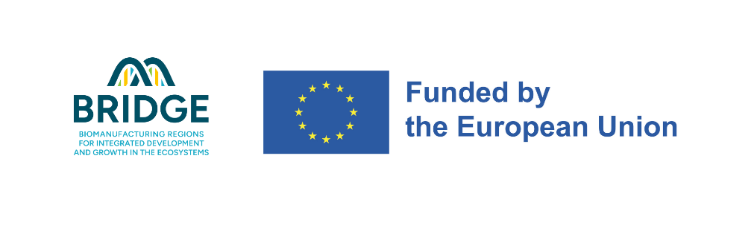
This project has received funding from the European Union’s I3,
under the Grant Agreement No.
101225477.
SME IDENTIFICATION:
Official name of the Company
Registered Office Address:
Registration/VAT Number:

SME QUALIFICATION CRITERIA:
To qualify as an SME, the entity must meet EU SME definitions as per the Recommendation 2003/361/EC. Please check the applicable category:

- Micro-enterprise: Fewer than 10 employees and ≤ €2 million turnover/balance sheet
- Small enterprise: Fewer than 50 employees and ≤ €10 million turnover/balance sheet
- Medium-sized enterprise: Fewer than 250 employees and ≤ €50 million turnover/balance sheet

FINANCIAL DATA (Last Closed Financial Year):
Year | Annual Turnover (€) | Number of Employees | Balance Sheet Total (€)
*Y | [Insert Value] | [Insert Value] | [Insert Value]

SME STATUS DECLARATION:
I, the undersigned, representing [Insert SME Name], declare that:
- The entity qualifies as an SME under EU law.
- The entity meets all legal, financial, and employment thresholds required.
- The entity is not controlled by a large enterprise beyond the SME participation limits.

I confirm the accuracy of the information provided in this declaration.
Date/Month/Year
Signature here

[Legal Representative Name]
[Title]
[Company Name]

https://single-market-economy.ec.europa.eu/smes/sme-fundamentals/sme-definition_en

